Colours to work with depending on rendering on the site with other elements

**From** <https://color.adobe.com/>

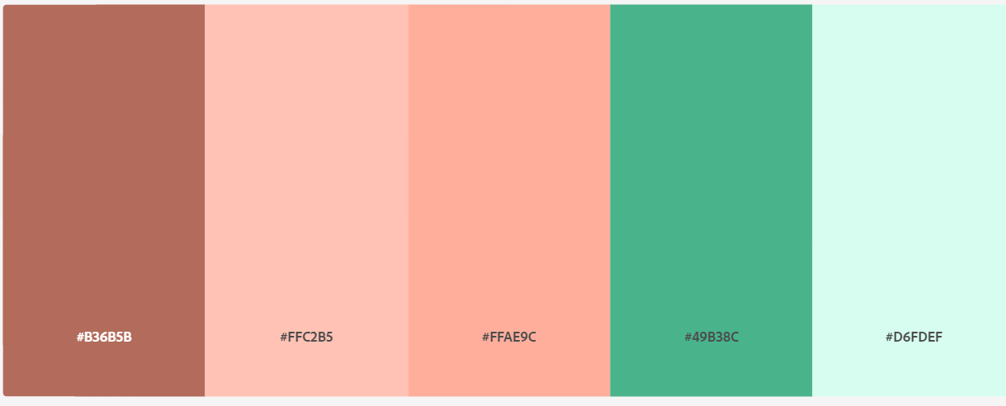

|  |  |  |  |  |
| --- | --- | --- | --- | --- |
| rgb(179, 107, 91) | rgb(255, 194, 181) | rgb(255, 174, 156) | rgb(73,179,140) | rgb(214,253, 239) |
| #B36B5B | #FFC2B5 | #FFAE9C | #49B38C | #D6FDEF |
| Logo | Not used too gender specific and not matching the rest of the site content | | Navbar, footer | Logo, Nav and footer font, social links |

**Logo –** created on <https://logomakr.com/> from default library

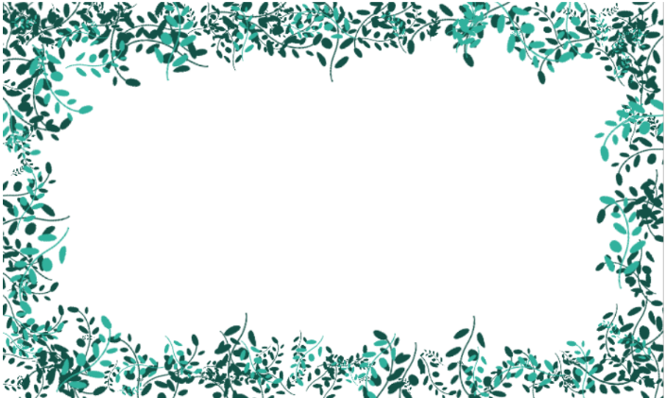**Cards images** – created in <https://sketch.io/sketchpad/>

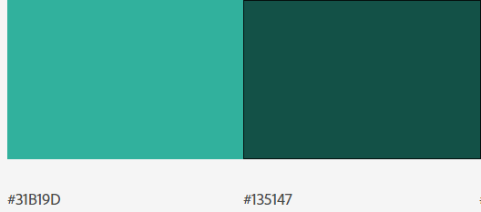

|  |  |
| --- | --- |
| rgb(49,177,157) | rgb(19,81,71) |
| #31B19D | #135147 |
| Stories images | Stories images, buttons, social media icons, hover effect on nav links |